Model: Basic logistic regression

Alpha: .3, iterations = 5000

Final training J = .68

Final Testing J = .767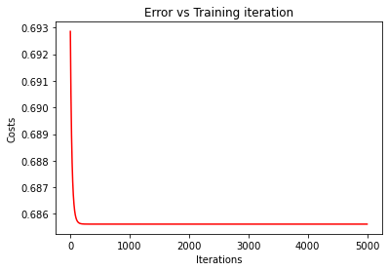

TP = 6

FP = 13

FN = 11

TN = 5

Accuracy = 31%

Precision = 32%

Recall = 35%

F1 = 33%